Jenkins CI/CD Pipeline
Part 1: Deploy Flask and Express on a Single EC2 Instance
Provisioning the EC2 Instance
- Launch an EC2 instance on AWS (a free-tier eligible instance is fine).
- SSH into the instance and install the dependencies: Python (for Flask), Node.js (for Express), and Git (for pulling the application code).
Application Setup
- Clone the Flask and Express repositories onto the EC2 instance.
- Install the required dependencies for both applications using pip and npm.
- Configure both applications to run on different ports (e.g., Flask on port 5000 and Express on port 3000).
- Start the applications using process managers like pm2 or systemd to ensure they remain active.
Deliverables
- A running EC2 instance with Flask and Express accessible via the instance's public IP.
- A description or diagram of the deployed architecture.
Created frontend/ and backend/ in Assignment9_CICD/Task/
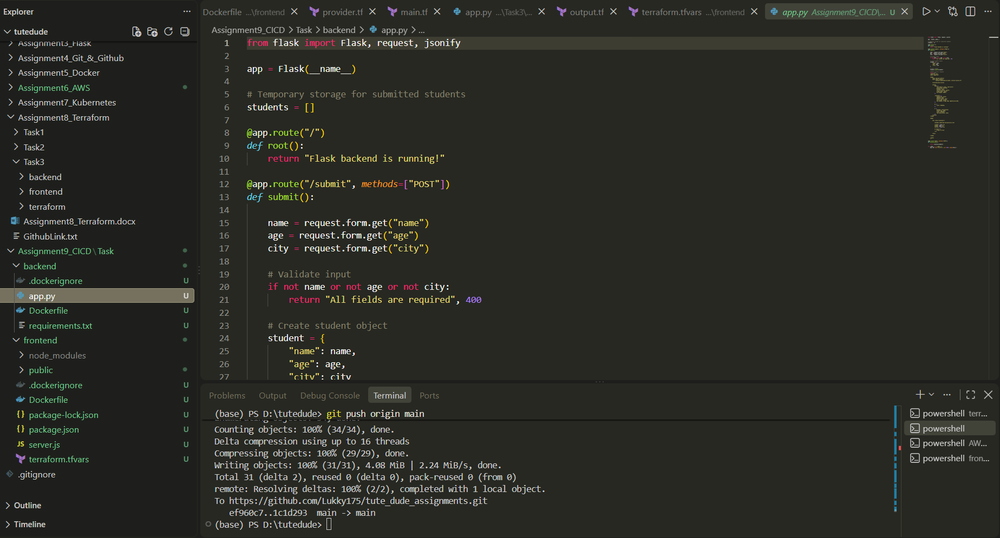
Created an EC2 Instance (“CICI_Application”)
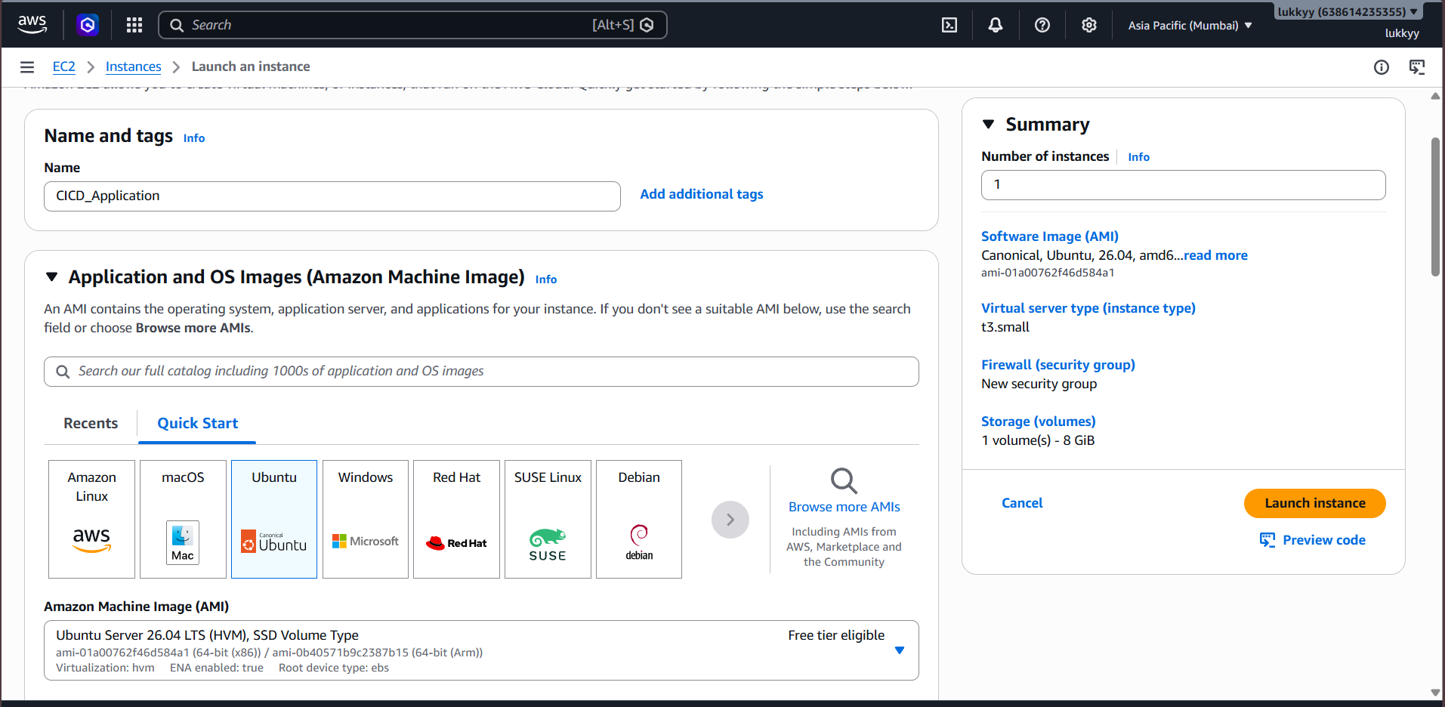
Connected to EC2 via ssh (ssh -i "Keypair-aws.pem" ubuntu@ec2-13-233-115-23.ap-south-1.compute.amazonaws.com)
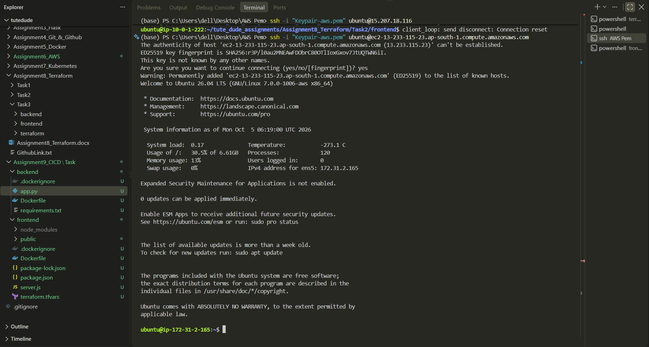

Installed Git, Python3, pip, venv
sudo apt install -y git
sudo apt install -y python3 python3-pip python3-venv
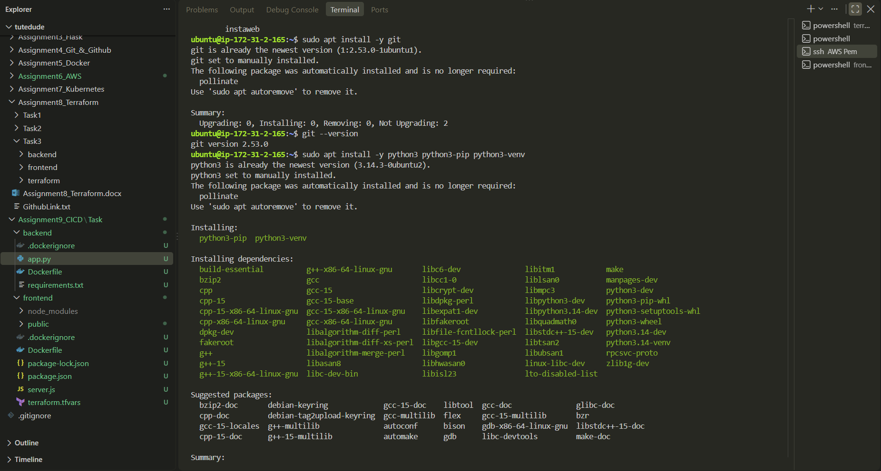
Created python virtual Environment & Activated it.
python3 -m venv venv
source venv/bin/activate
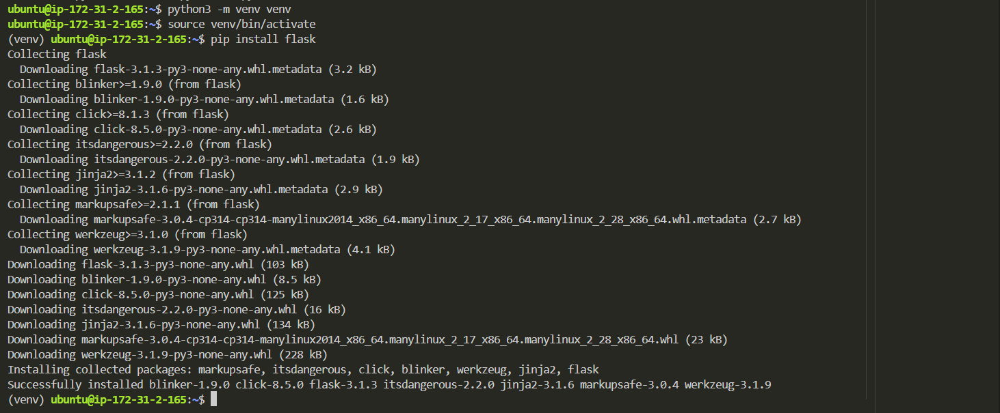
Created a new git repository and did git init in task/
Added a .gitignore and added pushed code to git repository https://github.com/Lukky175/Automated_CICD_Application_Repo.git
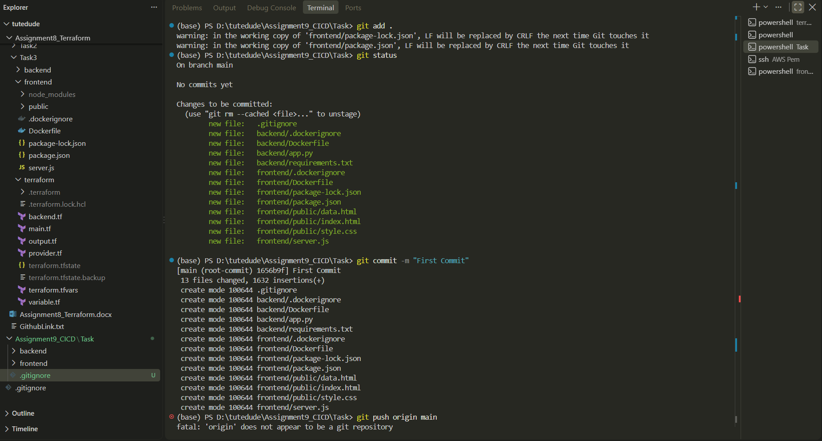
Did git clone https://github.com/Lukky175/Automated_CICD_Application_Repo.git
From the EC2
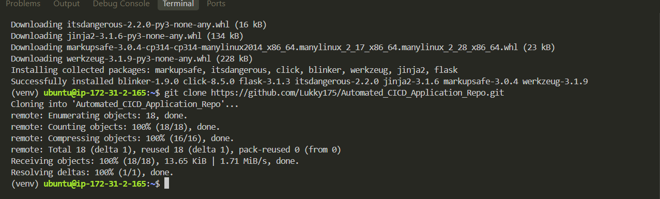

Installed pip in the venv pip install --upgrade pip
Did pip install -r requirements.txt in backend/
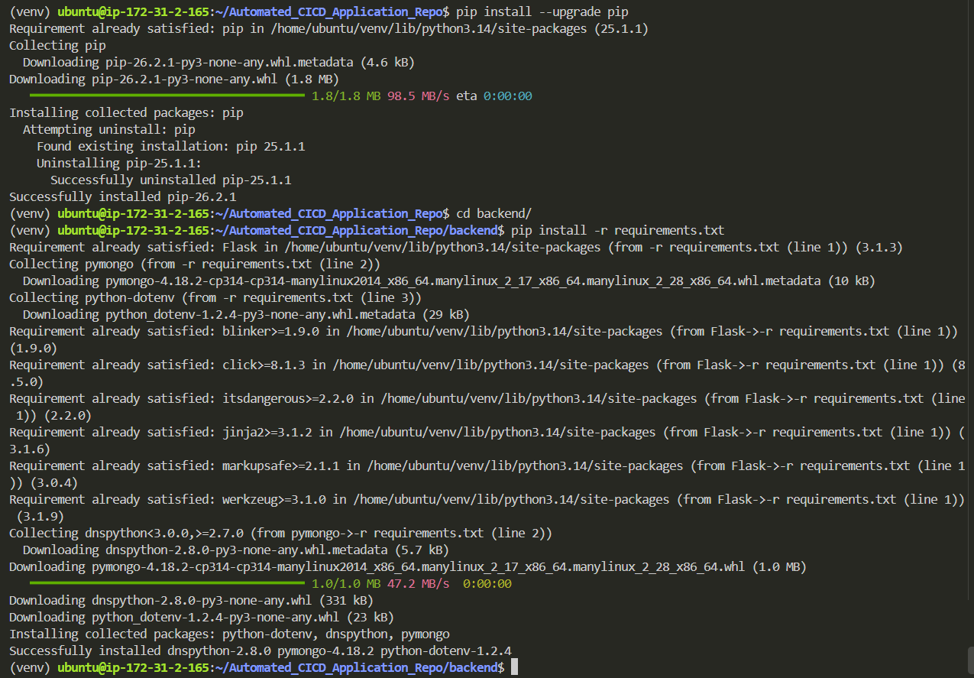
Did python3 app.py for testing
(App was running but Website was not loading)

Added Port 3000 & 5000 in security group.
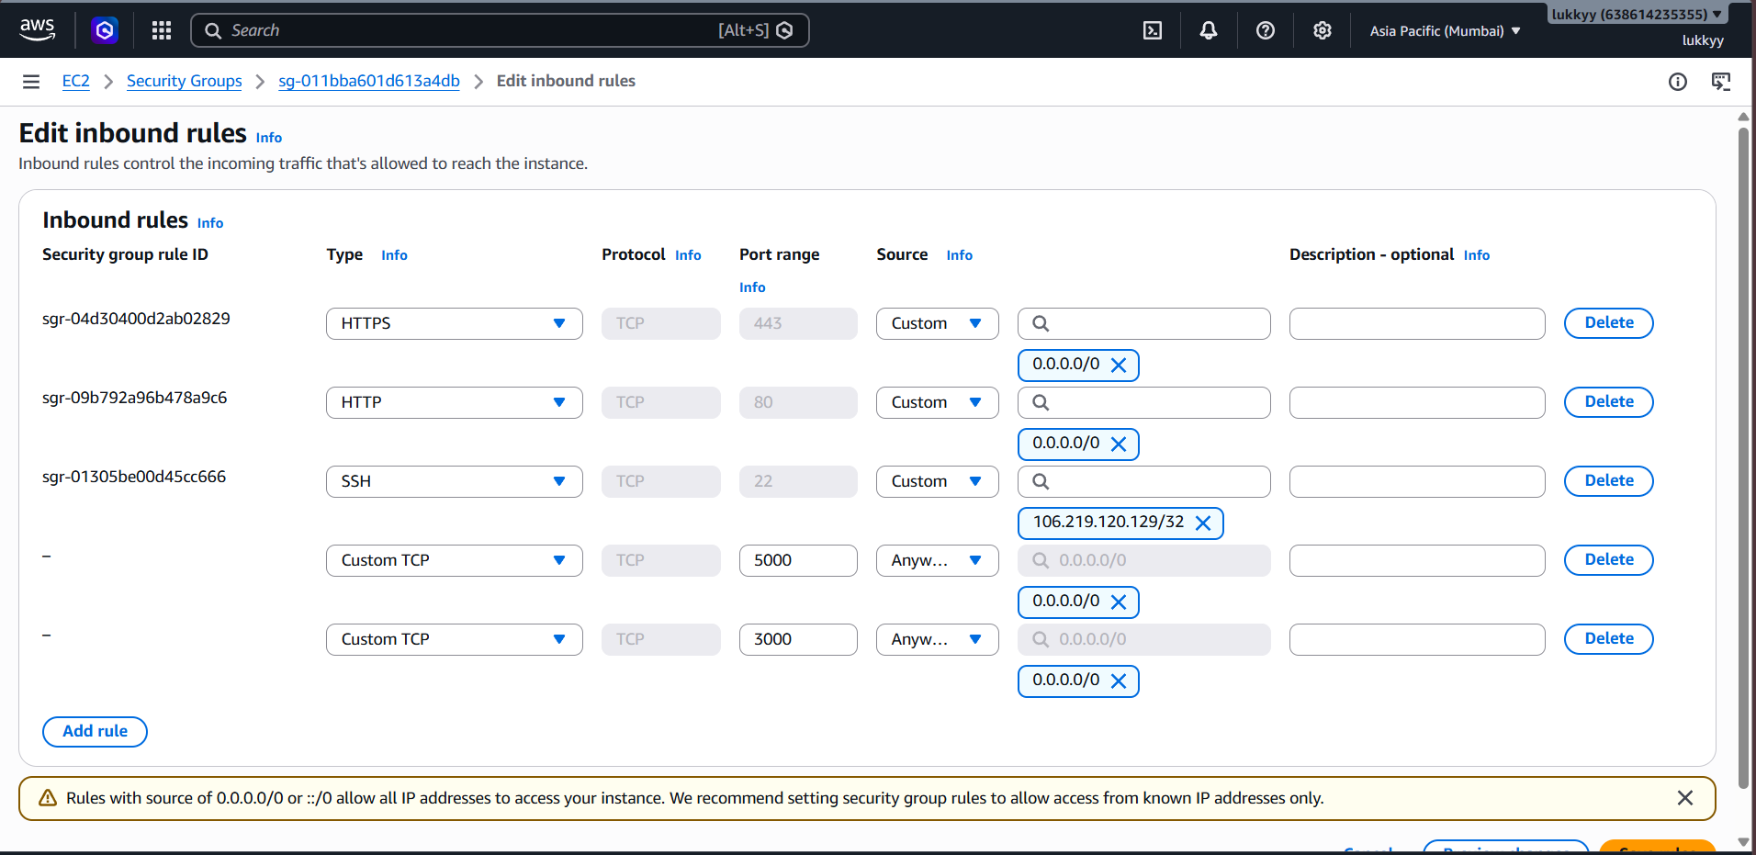
Backend running successfully
Backend ip -> http://13.233.115.23:5000/
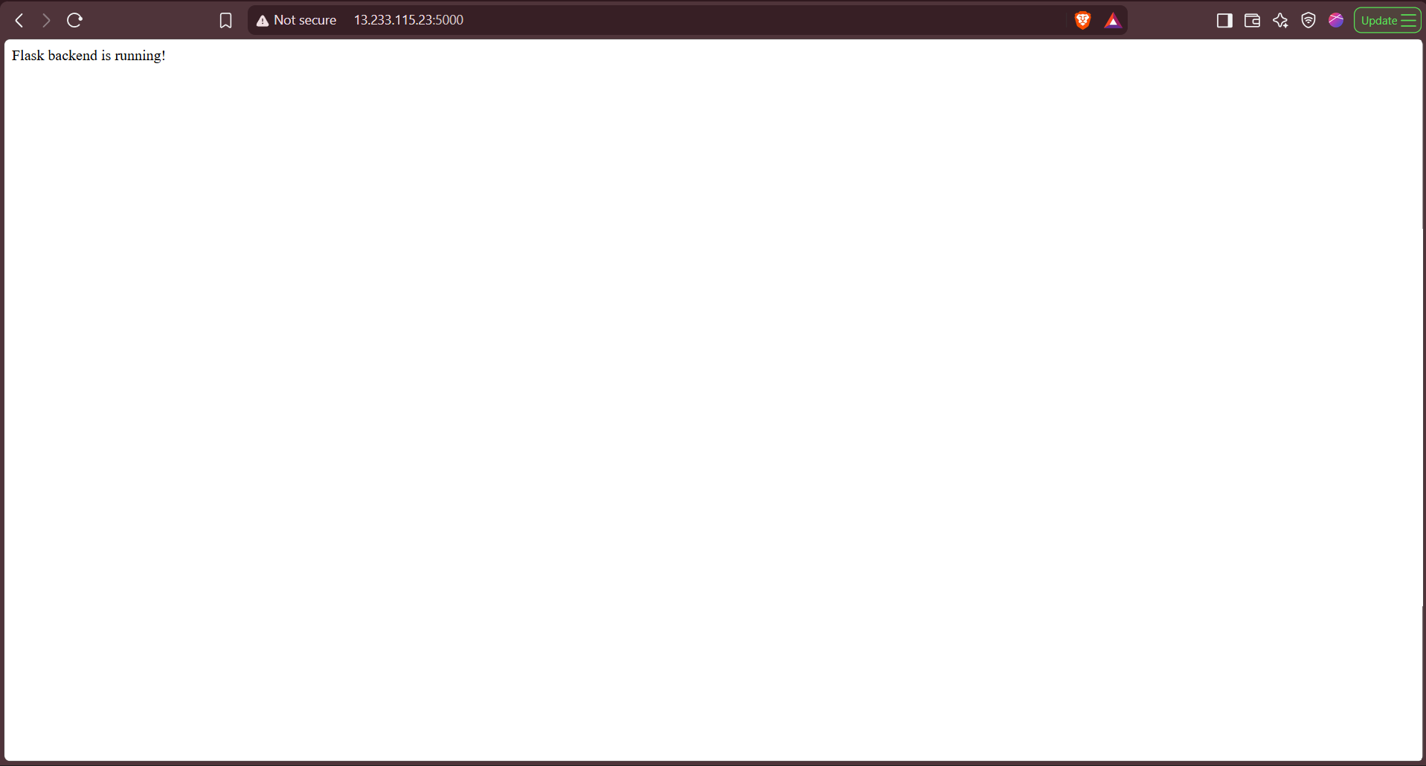
Did sudo apt install npm in frontend/
Did npm install
Did node server.js
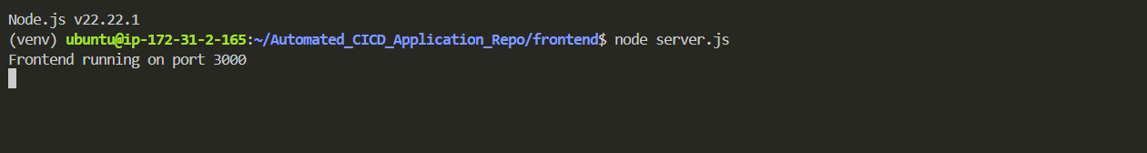
Frontend server running on ip http://13.233.115.23:3000/
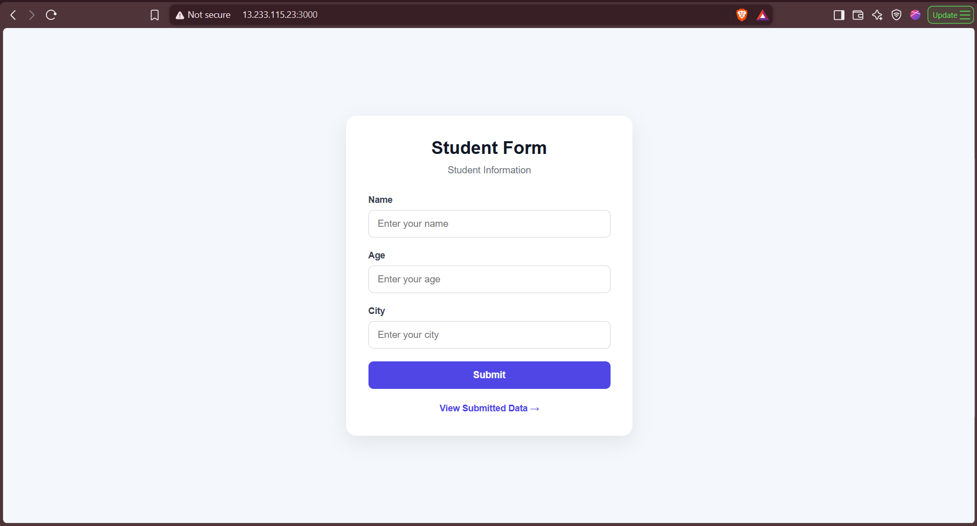
Did nohup node server.js > express.log 2>&1 & in frontend/
And did nohup python app.py > flask.log 2>&1 & in backend/ 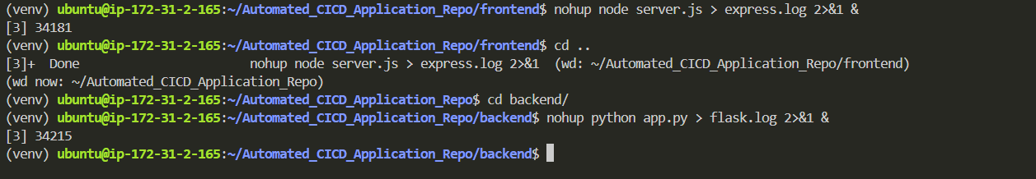
http://13.233.115.23:3000/ (frontend)
http://13.233.115.23:5000/ (backend)

Deployed Architecture
The Flask backend and Express frontend were deployed on a single Ubuntu 26.04 Amazon EC2 instance. The EC2 instance acts as the application server and hosts both applications simultaneously on different ports.
The Flask backend runs on port 5000 and is configured to listen on the EC2 instance's network interface so that it can be accessed through the instance's public IP address. A dedicated Python virtual environment (venv) is used for the Flask application to isolate its Python dependencies from the system Python environment.
The Express frontend runs on port 3000 and uses Node.js and npm for its runtime and dependency management. The application is configured to listen on the EC2 instance's network interface and can be accessed using the EC2 public IP address and port 3000.
Git is installed on the EC2 instance and is used to clone the application repositories. The required dependencies for both applications are installed separately using pip for Flask and npm for Express.
To ensure that the applications remain running continuously, process management is used. The Flask & Express applications are managed using nohup. Which allows the applications to automatically restart if they terminate unexpectedly and can also start them again when the EC2 instance is rebooted.
The EC2 instance's Security Group allows inbound traffic on ports 5000 and 3000, enabling external users to access the Flask backend and Express frontend through the EC2 instance's public IP address.
Therefore, the overall deployment consists of a single Ubuntu EC2 instance hosting two independent applications: the Flask backend on port 5000 and the Express frontend on port 3000, with their dependencies isolated and their processes managed for reliable operation.

Part 2: Implement CI/CD Pipeline Using Jenkins
Objective: Automate the deployment of the Flask and Express applications using Jenkins.
Install Jenkins
- Install Jenkins on the same EC2 instance or on a separate machine.
- Configure Jenkins by installing essential plugins like Git, NodeJS, and Python.
Set Up Jenkins Pipeline
- Create two separate Jenkins pipelines for the Flask and Express applications.
- Pipeline Steps: Pull the latest code from the respective Git repositories.
- Install dependencies for Flask (pip install -r requirements.txt) and Express (npm install).
- Restart the applications using the process manager (e.g., pm2 restart).
Triggering the Pipeline
- Set up a GitHub webhook to trigger the Jenkins pipeline on every push to the repositories.
Optional Enhancements
- Add testing stages to the pipeline for both applications.
- Configure environment variables in Jenkins for managing sensitive data like API keys.
Deliverables
- A fully functional CI/CD pipeline that automates the deployment process for Flask and Express.
- A Jenkins pipeline script (Jenkinsfile) for each application.
- Evidence of the pipeline working (e.g., screenshots of successful builds and deployments).

Installing Jenkins on EC2
sudo apt update
sudo apt upgrade -y
sudo apt install openjdk-21-jre -y (Checking java version with java -version)
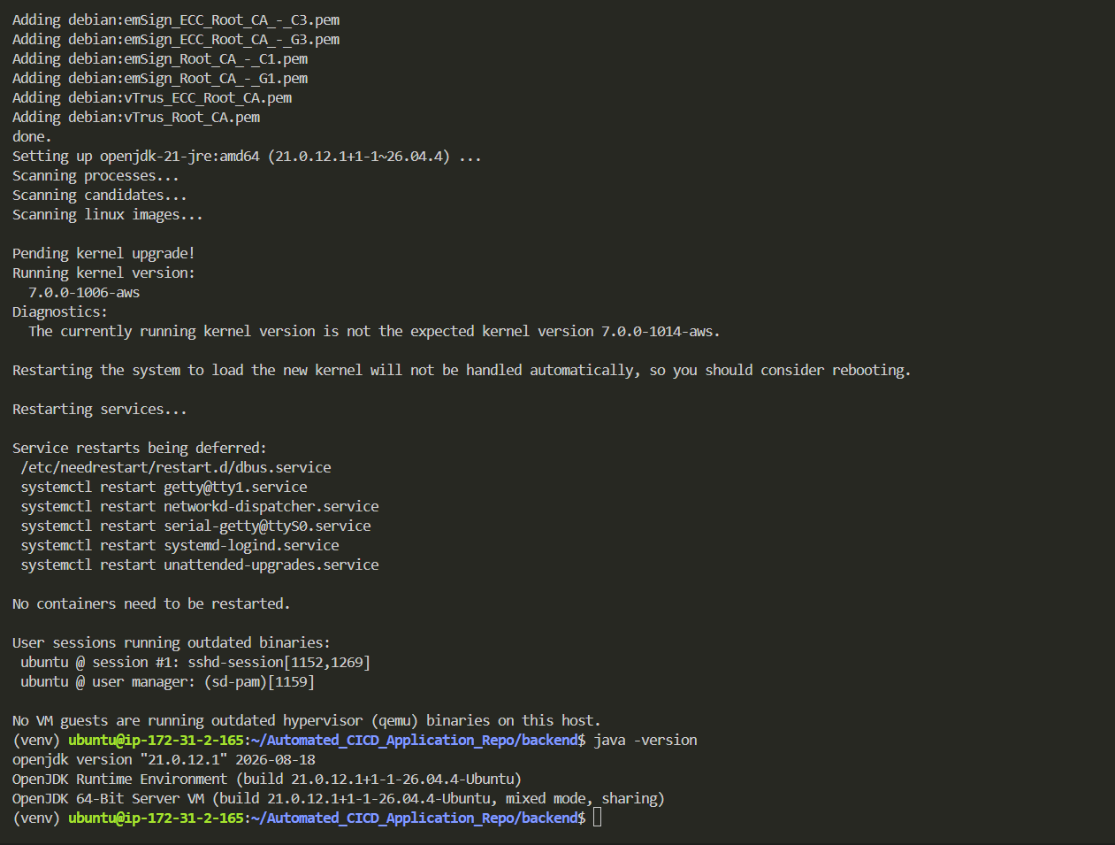
Downloading Jenkins gpg key and download it
curl -fsSL https://pkg.jenkins.io/debian-stable/jenkins.io-2026.key | sudo tee /etc/apt/keyrings/jenkins-keyring.asc > /dev/null
Adding Jenkins Repository
echo "deb [signed-by=/etc/apt/keyrings/jenkins-keyring.asc] https://pkg.jenkins.io/debian-stable binary/" | sudo tee /etc/apt/sources.list.d/jenkins.list > /dev/null

sudo apt update
sudo apt install jenkins -y
sudo systemctl start jenkins
sudo systemctl enable jenkins
sudo systemctl status jenkins
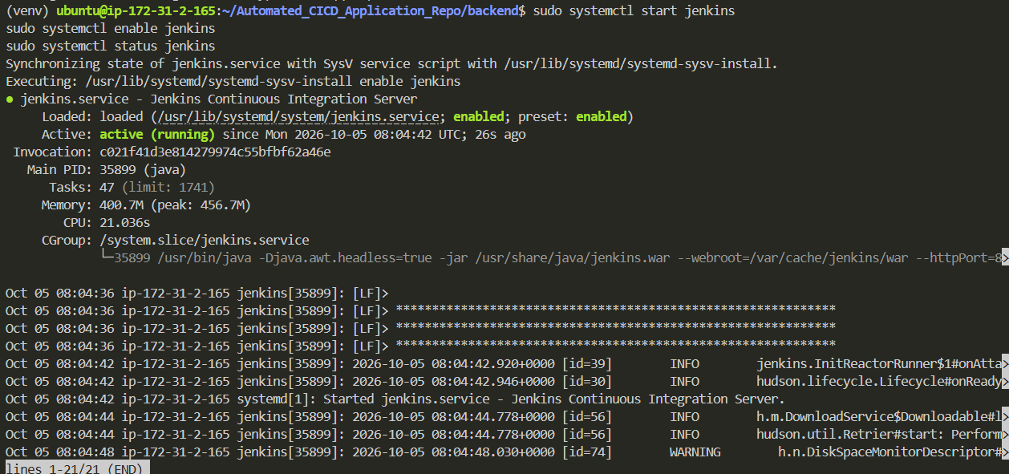
Updated Security Group
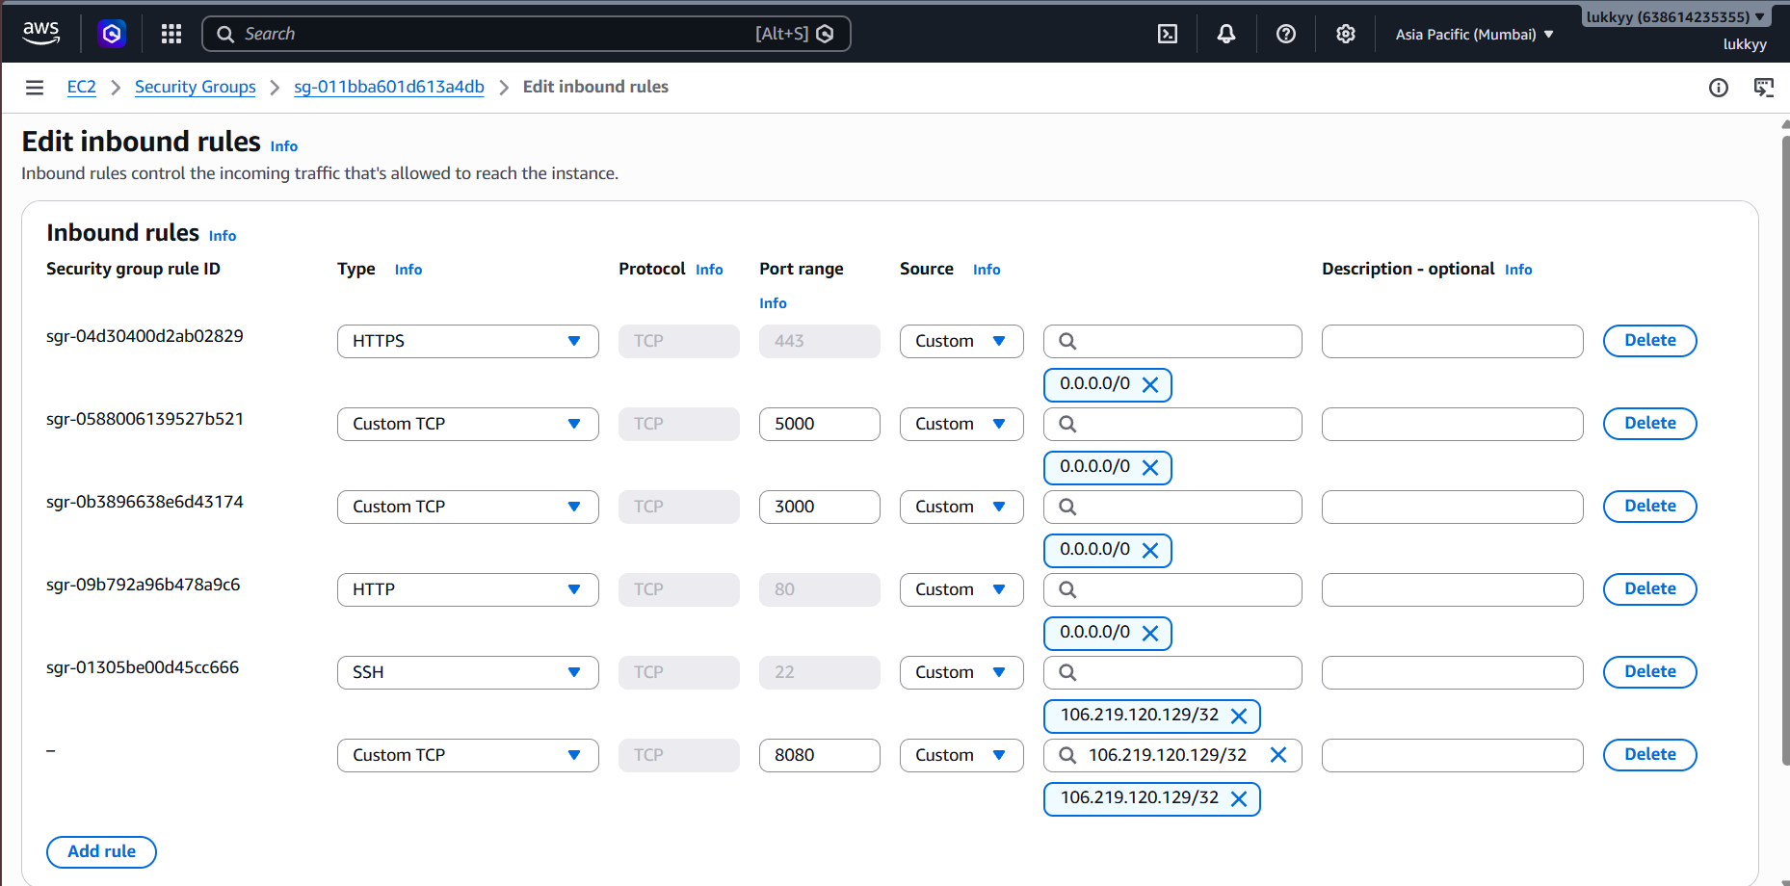
Did sudo cat /var/lib/jenkins/secrets/initialAdminPassword
Installing Plugins
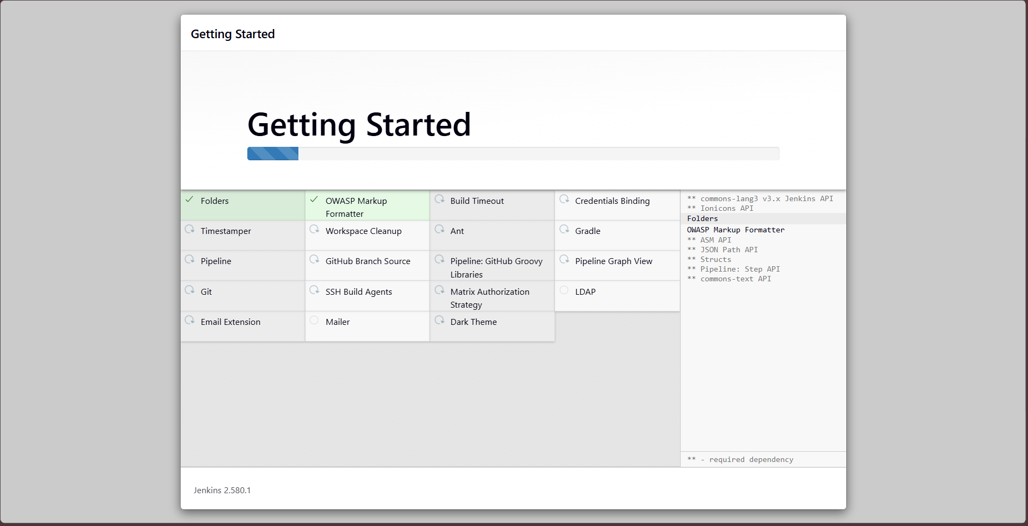

In built-in nodes there was an issue Disk space is below threshold of 1.00 GiB. Only 947.86 MiB out of 952.61 MiB left on /tmp.
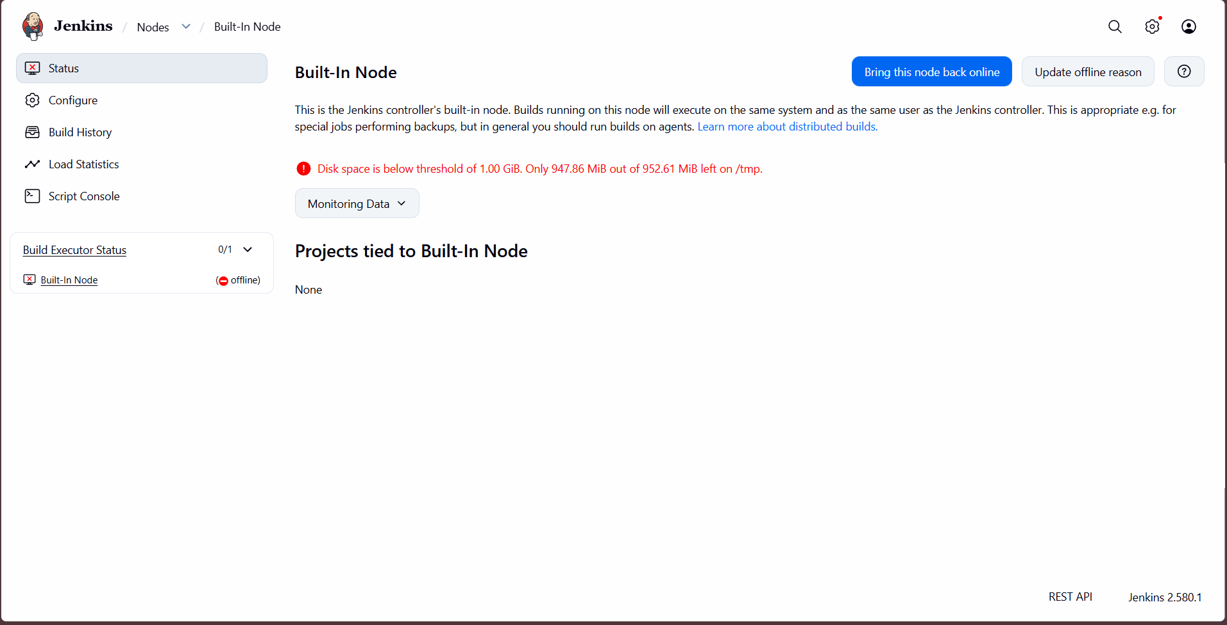
Created a new EC2 with more disk space and setting up everything again
New EC2
name - CICD2_Application
AMI - ami-01a00762f46d584a1 (Ubuntu, 26.04)
Instance Type - c7i-flex.large
Storage volume - 25gb

New backend ip -> http://13.127.69.195:5000/
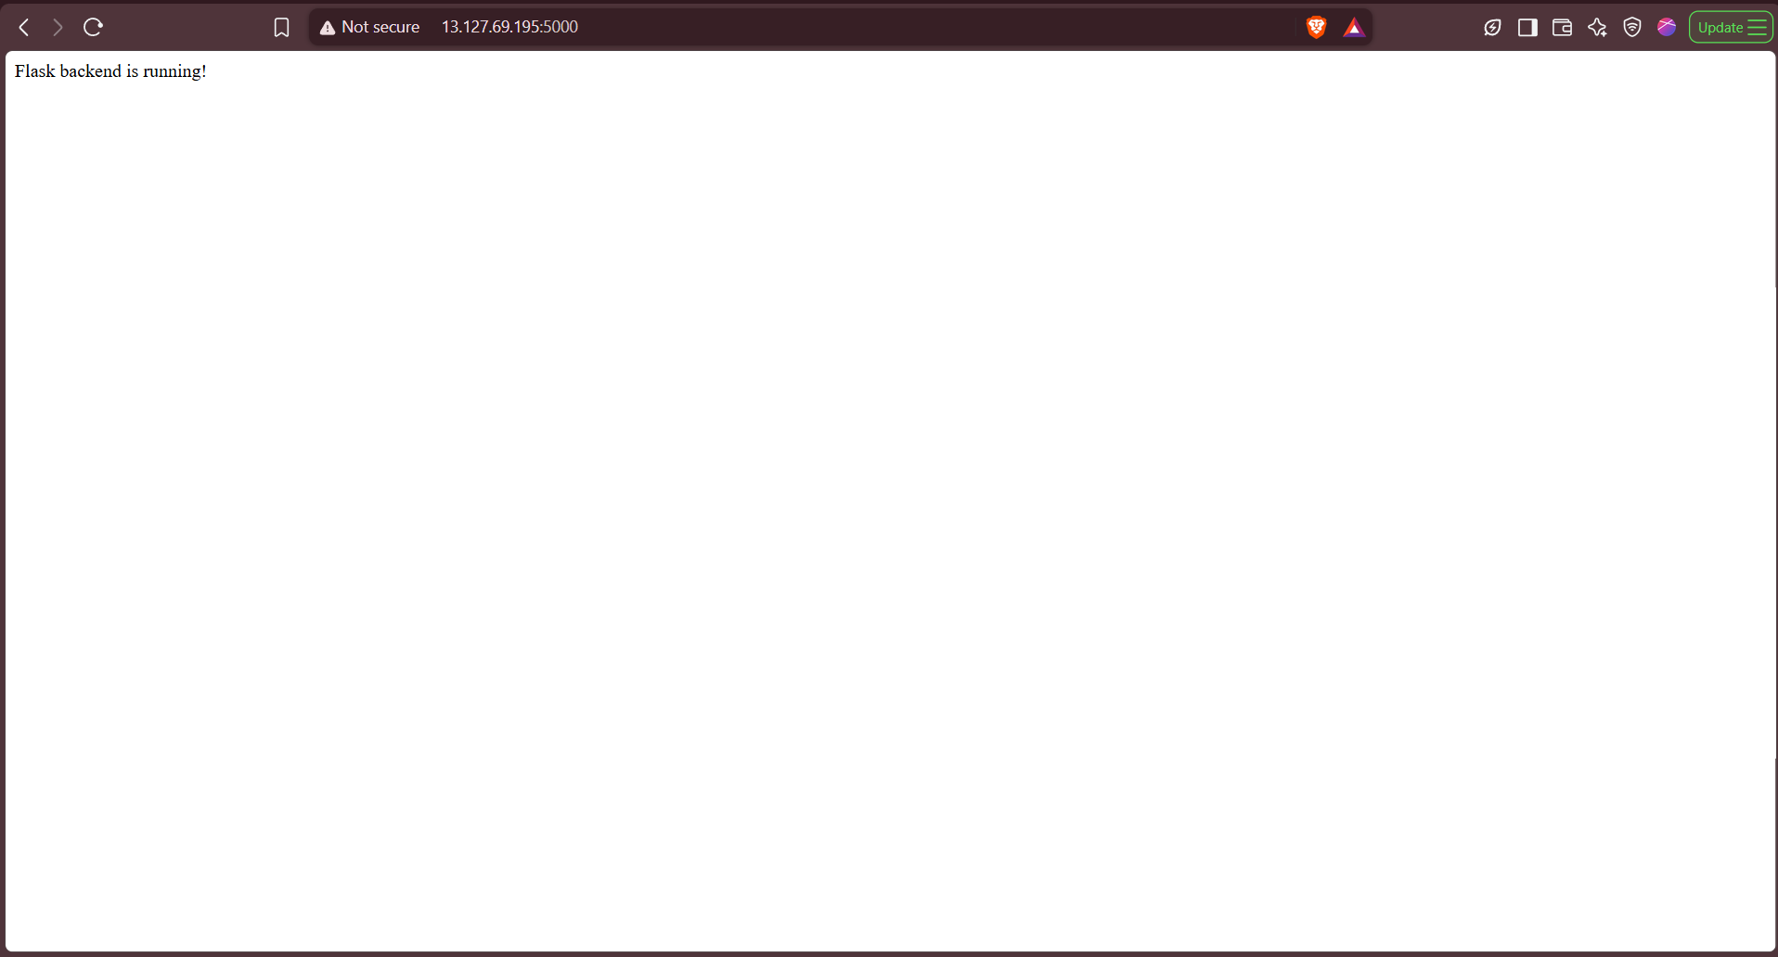
New frontend ip -> http://13.127.69.195:3000/
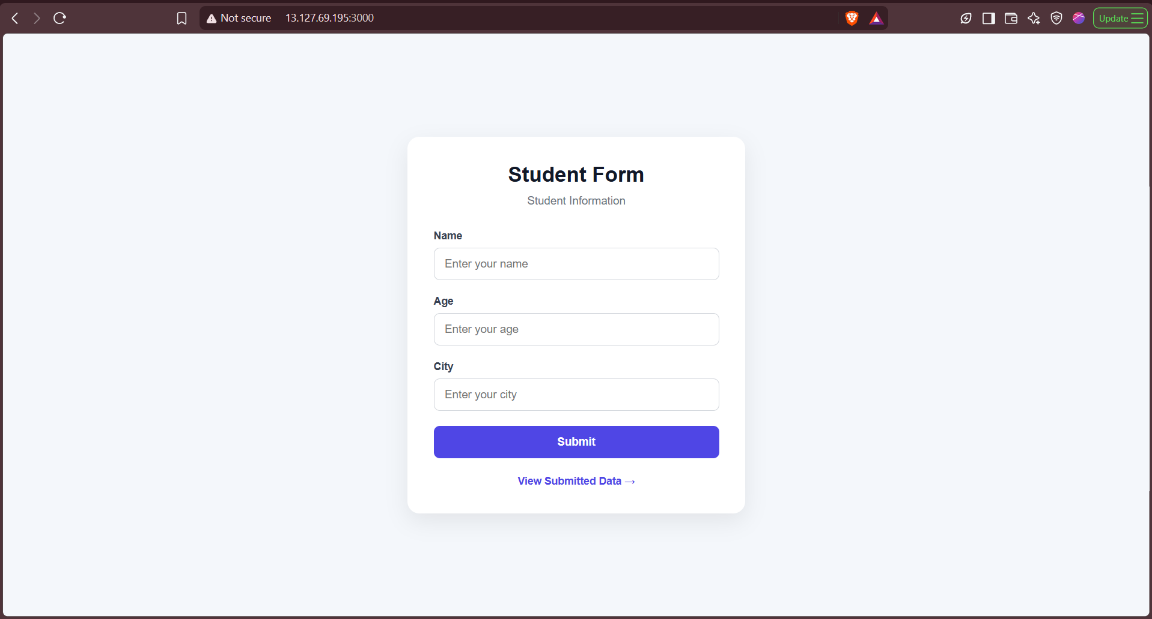
Jenkins is running on Server ip -> http://13.127.69.195:8080/
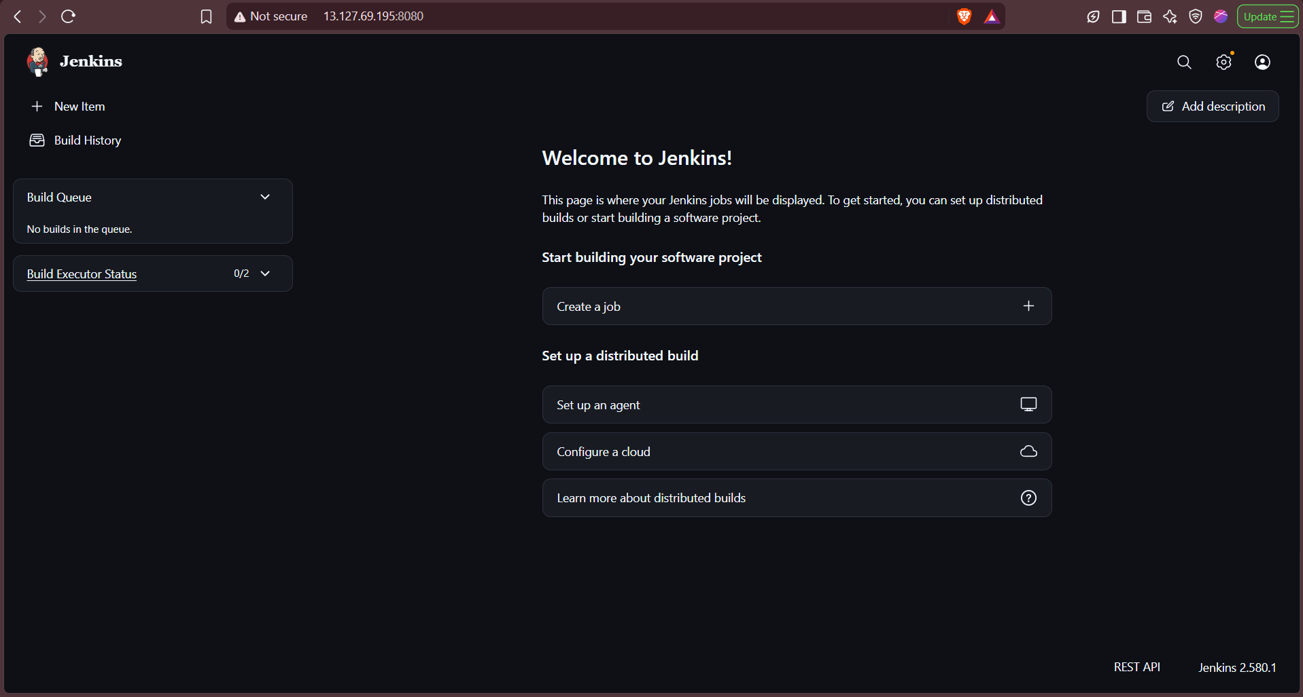
Installed Git, NodeJS, and Python Plugins

1. Remove old nohup processes
For Flask:
ps aux | grep '[p]ython.*app.py'
sudo ss -ltnp | grep ':5000'
kill <FLASK_PID>

For Express:
sudo ss -ltnp | grep ':3000'
ps aux | grep -E 'node.*server.js|npm.*start|nohup' | grep -v grep
kill <EXPRESS_PID>

2. Create systemd service for Flask
sudo nano /etc/systemd/system/flask-app.service
[Unit]
Description=Flask Backend Application
After=network.target

[Service]
User=ubuntu
WorkingDirectory=/home/ubuntu/Automated_CICD_Application_Repo/backend
Environment="PATH=/home/ubuntu/venv/bin:/usr/local/bin:/usr/bin:/bin"
ExecStart=/home/ubuntu/venv/bin/python /home/ubuntu/Automated_CICD_Application_Repo/backend/app.py
Restart=always
RestartSec=5

[Install]
WantedBy=multi-user.target
sudo systemctl daemon-reload
sudo systemctl enable flask-app
sudo systemctl start flask-app
sudo systemctl status flask-app --no-pager
Verify:
sudo ss -ltnp | grep ':5000'

3. Install and configure PM2 for Express
sudo npm install -g pm2
cd ~/Automated_CICD_Application_Repo/frontend
pm2 start server.js --name express-app
pm2 save
pm2 startup
Run the sudo command shown by pm2 startup, then:
pm2 save
pm2 status
Verify:
sudo ss -ltnp | grep ':3000'

Final setup
Flask :5000 → systemd → flask-app.service
Express :3000 → PM2 → express-app
No nohup processes are used anymore.

Check Jenkins Status
sudo systemctl status jenkins --no-pager

Add permission for Ubuntu to see files
sudo chmod 755 /home/ubuntu
chmod -R 777 /home/ubuntu/Automated_CICD_Application_Repo (Giving permission to Jenkins)

Allow Jenkins to restart apps
sudo visudo

jenkins ALL=(ALL) NOPASSWD: /usr/bin/systemctl restart flask-app
jenkins ALL=(ubuntu) NOPASSWD: /usr/local/bin/pm2 restart express-app

Create backend/Jenkinsfile
pipeline {
agent any

environment {
DEPLOY_DIR = '/home/ubuntu/Automated_CICD_Application_Repo/backend'
VENV_PYTHON = '/home/ubuntu/venv/bin/python'
VENV_PIP = '/home/ubuntu/venv/bin/pip'
}

stages {
stage('Checkout') {
steps {
checkout scm
}
}

stage('Verify Backend Files') {
steps {
sh '''
set -e

echo "Checking backend files..."

test -f backend/app.py || {
echo "ERROR: backend/app.py not found"
exit 1
}

test -f backend/requirements.txt || {
echo "ERROR: backend/requirements.txt not found"
exit 1
}

echo "Backend files verified."
'''
}
}

stage('Install Dependencies') {
steps {
sh '''
set -e

echo "Installing Python dependencies..."

$VENV_PIP install -r backend/requirements.txt

echo "Dependencies installed successfully."
'''
}
}

stage('Syntax Check') {
steps {
sh '''
set -e

echo "Running Python syntax check..."

$VENV_PYTHON -m py_compile backend/app.py

echo "Python syntax check passed."
'''
}
}

stage('Test Application') {
steps {
sh '''
set -e

echo "Testing Flask application..."

$VENV_PYTHON -c "import sys; sys.path.insert(0, 'backend'); import app; print('Flask application imported successfully')"

echo "Application test passed."
'''
}
}

stage('Deploy Backend') {
steps {
sh '''
set -e

echo "Deploying backend..."

sudo -u ubuntu cp backend/app.py "$DEPLOY_DIR/app.py"
sudo -u ubuntu cp backend/requirements.txt "$DEPLOY_DIR/requirements.txt"

echo "Backend deployed successfully."
'''
}
}

stage('Restart Flask') {
steps {
sh '''
set -e

echo "Restarting Flask service..."

sudo systemctl restart flask-app

echo "Waiting for Flask service..."
sleep 3

if ! sudo systemctl is-active --quiet flask-app; then
echo "ERROR: Flask service failed to start."
sudo systemctl status flask-app --no-pager
exit 1
fi

echo "Flask service is running."
'''
}
}

stage('Deployment Health Check') {
steps {
sh '''
set -e

echo "Checking Flask application on port 5000..."

if ! curl -f --max-time 10 http://127.0.0.1:5000/; then
echo "ERROR: Flask health check failed."
exit 1
fi

echo ""
echo "Flask deployment successful."
'''
}
}
}

post {
success {
echo 'Flask CI/CD pipeline completed successfully.'
}

failure {
echo 'Flask CI/CD pipeline failed. Application was not considered successfully deployed.'
}
}
}

Created Pipeline Job named Flask-CI-CD
Description - CI/CD pipeline for the Flask backend application.
Checked -> GitHub hook trigger for GITScm polling
In pipeline did Pipeline script from SCM
Repository URL -> https://github.com/Lukky175/Automated_CICD_Application_Repo.git
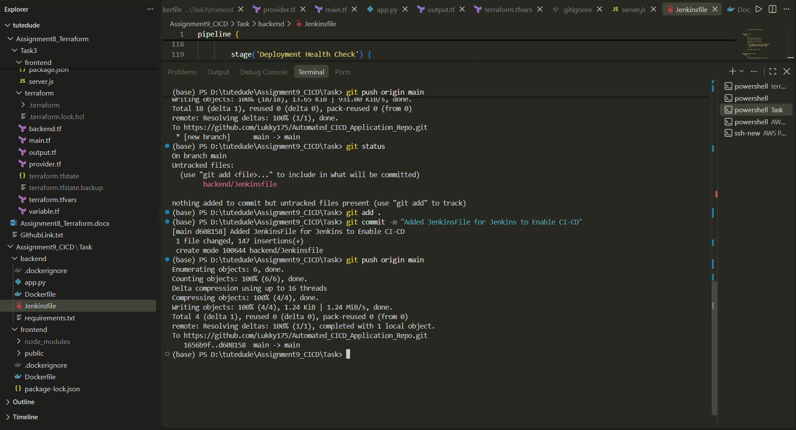
Clicked Save and Pipeline is Created

Create a Deployment Script
sudo nano /usr/local/bin/deploy-flask
#!/bin/bash

set -e

cp /var/lib/jenkins/workspace/Flask-CI-CD/backend/app.py \
/home/ubuntu/Automated_CICD_Application_Repo/backend/app.py

cp /var/lib/jenkins/workspace/Flask-CI-CD/backend/requirements.txt \
/home/ubuntu/Automated_CICD_Application_Repo/backend/requirements.txt

systemctl restart flask-app

sudo chown root:root /usr/local/bin/deploy-flask
sudo chmod 755 /usr/local/bin/deploy-flask

Do `sudo visudo` and add the following line at bottom.
jenkins ALL=(root) NOPASSWD: /usr/local/bin/deploy-flask

Added a webhook in Github
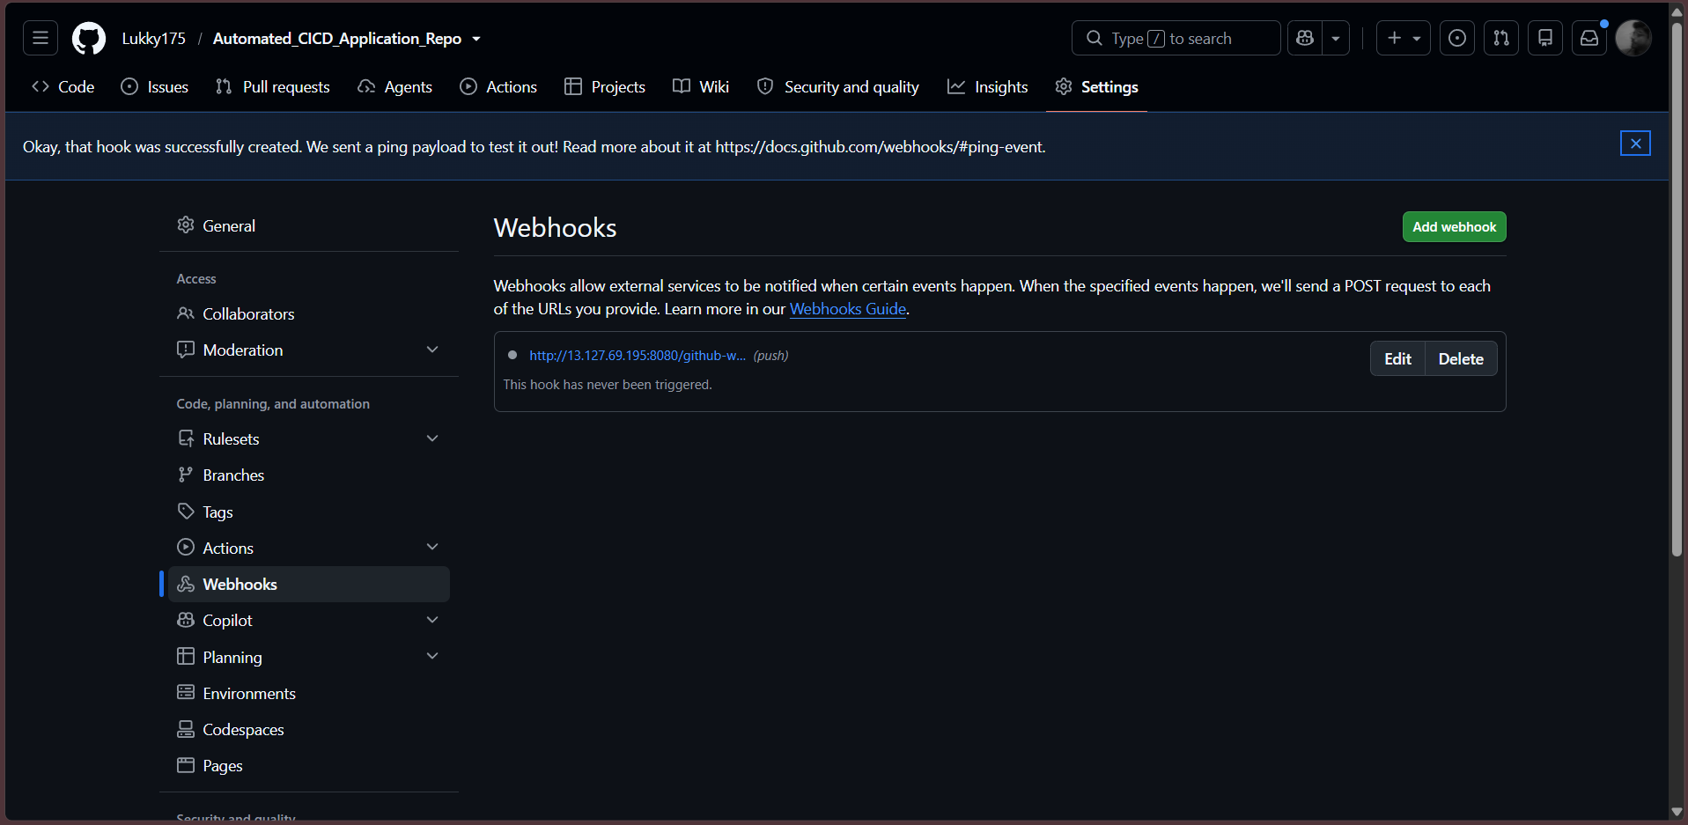

Made a push in Repo.
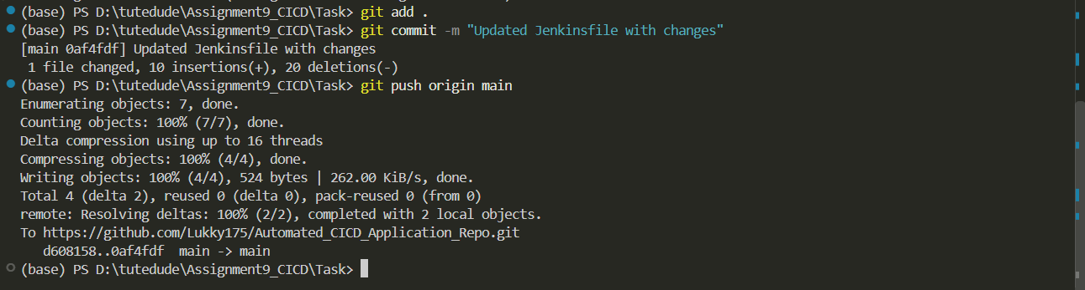
Pipeline running
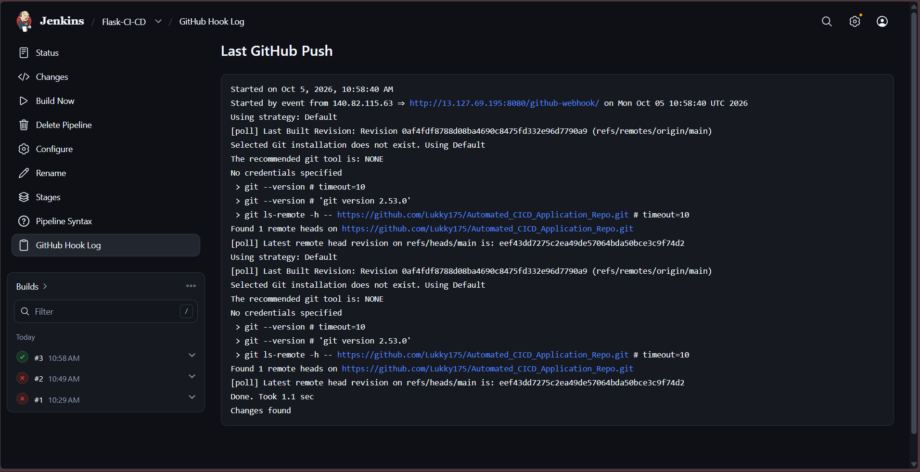

Create frontend/Jenkinsfile
pipeline {
agent any

environment {
DEPLOY_DIR = '/home/ubuntu/Automated_CICD_Application_Repo/frontend'
NODE_BIN = '/usr/bin/node'
NPM_BIN = '/usr/bin/npm'
}

stages {

stage('Checkout') {
steps {
checkout scm
}
}

stage('Verify Frontend Files') {
steps {
sh '''
set -e

echo "Checking frontend files..."

test -f frontend/server.js || {
echo "ERROR: frontend/server.js not found"
exit 1
}

test -f frontend/package.json || {
echo "ERROR: frontend/package.json not found"
exit 1
}

test -f frontend/package-lock.json || {
echo "ERROR: frontend/package-lock.json not found"
exit 1
}

echo "Frontend files verified."
'''
}
}

stage('Install Dependencies') {
steps {
sh '''
set -e

echo "Installing Node.js dependencies..."

cd frontend
npm install

echo "Dependencies installed successfully."
'''
}
}

stage('Syntax Check') {
steps {
sh '''
set -e

echo "Running JavaScript syntax check..."

node --check frontend/server.js

echo "JavaScript syntax check passed."
'''
}
}

stage('Application Check') {
steps {
sh '''
set -e

echo "Checking Express application..."

cd frontend

node -e "
const app = require('./server.js');
console.log('Express application loaded successfully');
"

echo "Application check passed."
'''
}
}

stage('Deploy & Restart Express') {
steps {
sh '''
set -e

echo "Deploying frontend..."

sudo /usr/local/bin/deploy-express

echo "Waiting for Express application..."
sleep 3

echo "Express deployment completed."
'''
}
}

stage('Deployment Health Check') {
steps {
sh '''
set -e

echo "Checking Express application on port 3000..."

if ! curl -f --max-time 10 http://127.0.0.1:3000/; then
echo "ERROR: Express health check failed."
exit 1
fi

echo ""
echo "Express deployment successful."
'''
}
}
}

post {
success {
echo 'Express CI/CD pipeline completed successfully.'
}

failure {
echo 'Express CI/CD pipeline failed.'
}
}
}

Created a Deployment Script
sudo nano /usr/local/bin/deploy-express
#!/bin/bash

set -e

SOURCE="/var/lib/jenkins/workspace/Express-CI-CD/frontend/"
DEST="/home/ubuntu/Automated_CICD_Application_Repo/frontend/"

echo "Starting Express deployment..."

echo "Removing old frontend files..."
rm -rf "${DEST:?}"*

echo "Copying latest frontend files from Jenkins workspace..."
rsync -av \
--exclude='.git' \
--exclude='node_modules' \
"$SOURCE""$DEST"

echo "Installing Node.js dependencies..."
cd "$DEST"
sudo -u ubuntu npm install

echo "Restarting Express application..."
sudo -u ubuntu /usr/local/bin/pm2 restart express-app --update-env

echo "Waiting for Express application..."
sleep 3

if ! sudo -u ubuntu /usr/local/bin/pm2 describe express-app | grep -q "online"; then
echo "ERROR: Express application failed to start."
exit 1
fi

echo "Express application is running."
echo "Express deployment completed successfully."

sudo visudo (add on bottom)
jenkins ALL=(root) NOPASSWD: /usr/local/bin/deploy-express

Ran Frontend Pipeline
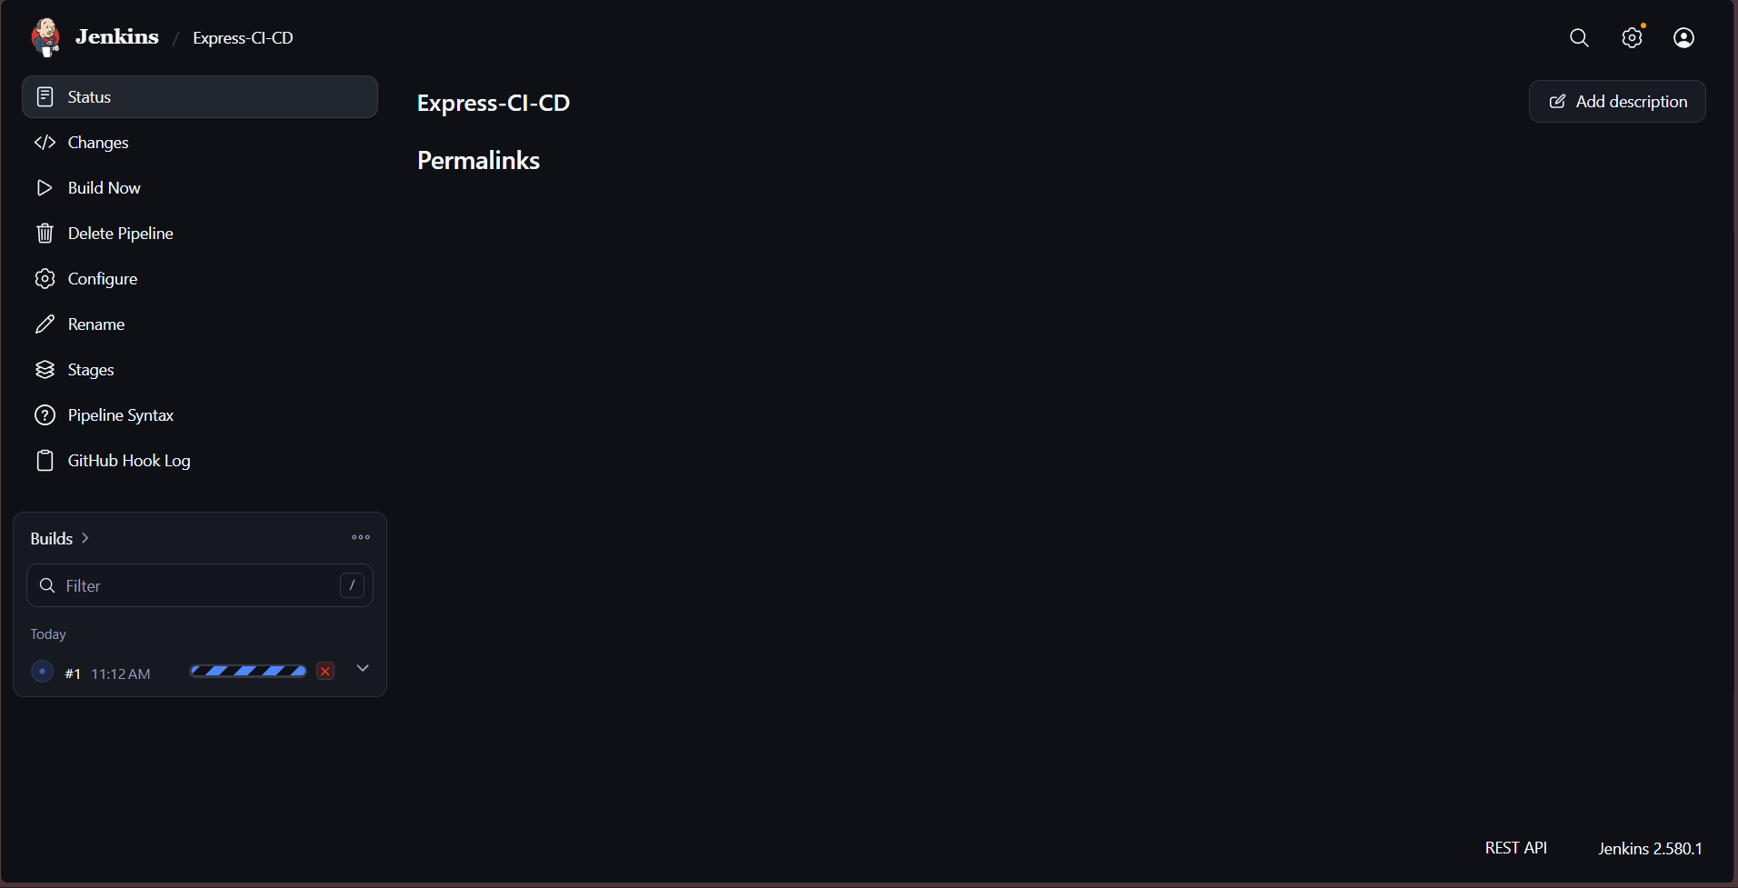

Frontend is Deployed
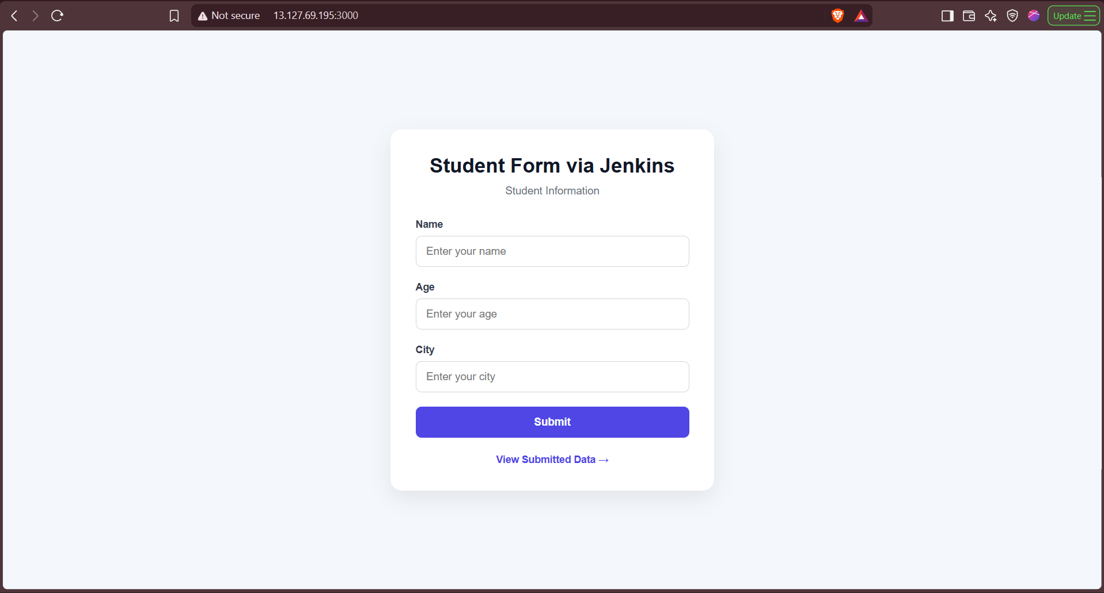

Now Testing our CI/CD pipeline, Making few Intentional Changes (Added Lukky in frontend and backend UI)
And pushing changes

Frontend
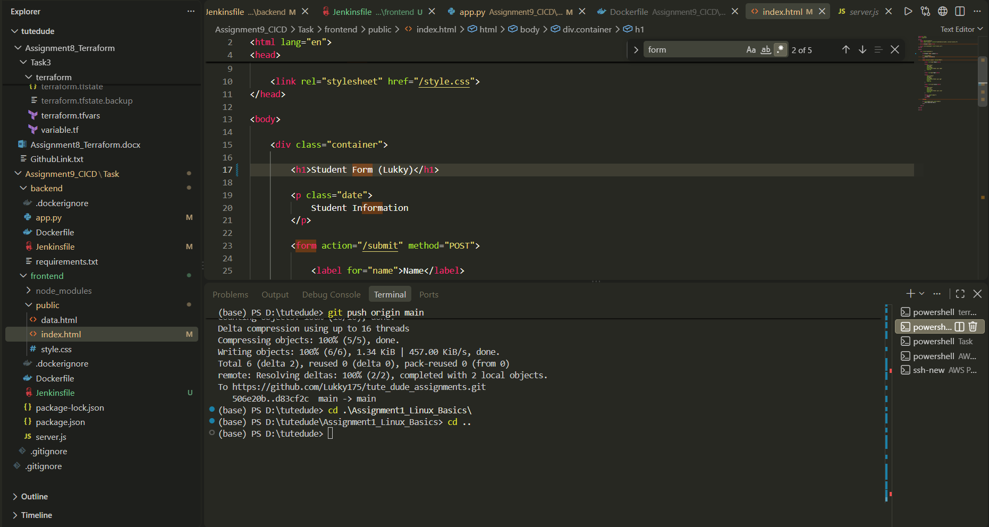
Backend
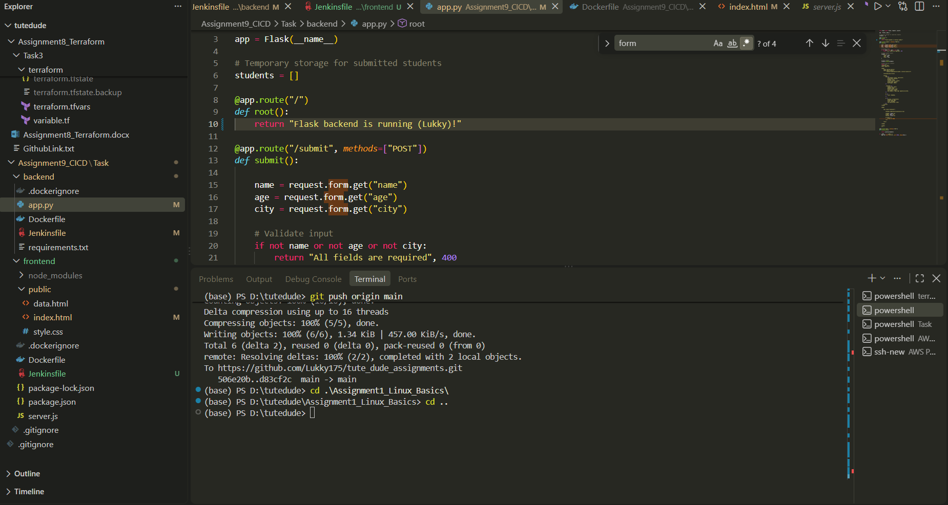

Pushing Changes to Github
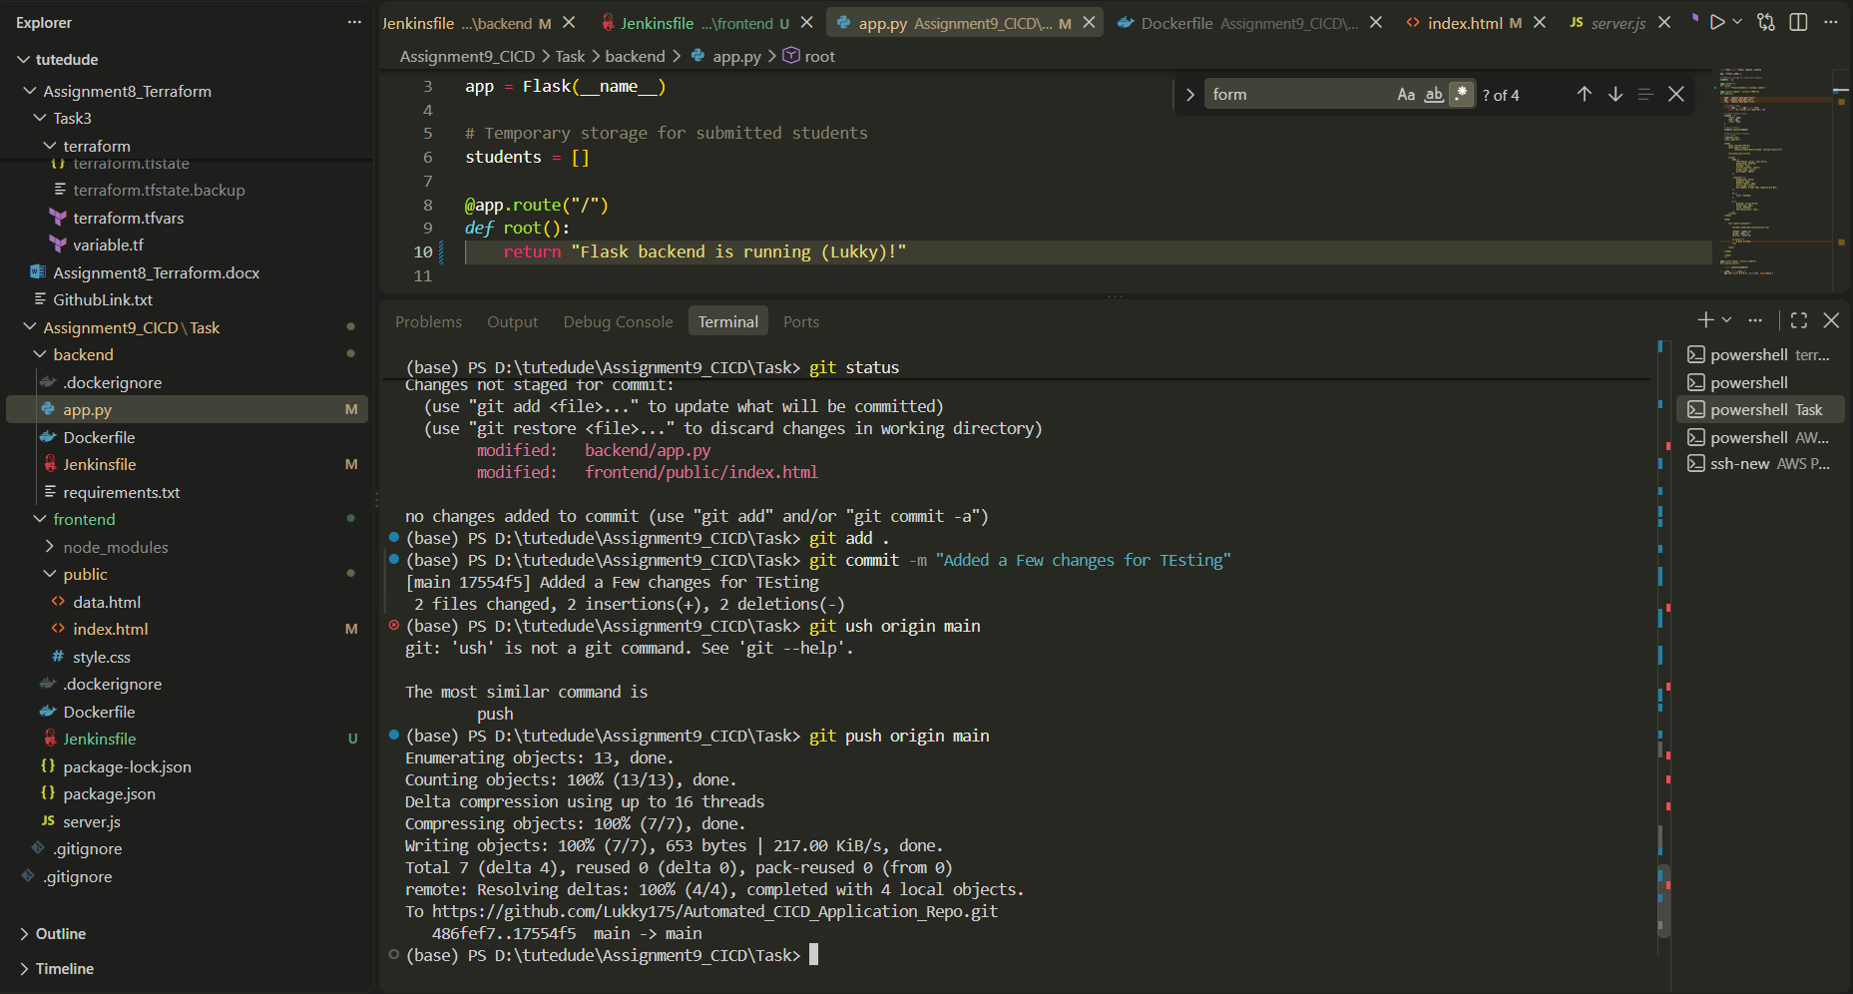

Frontend Pipeline Proof
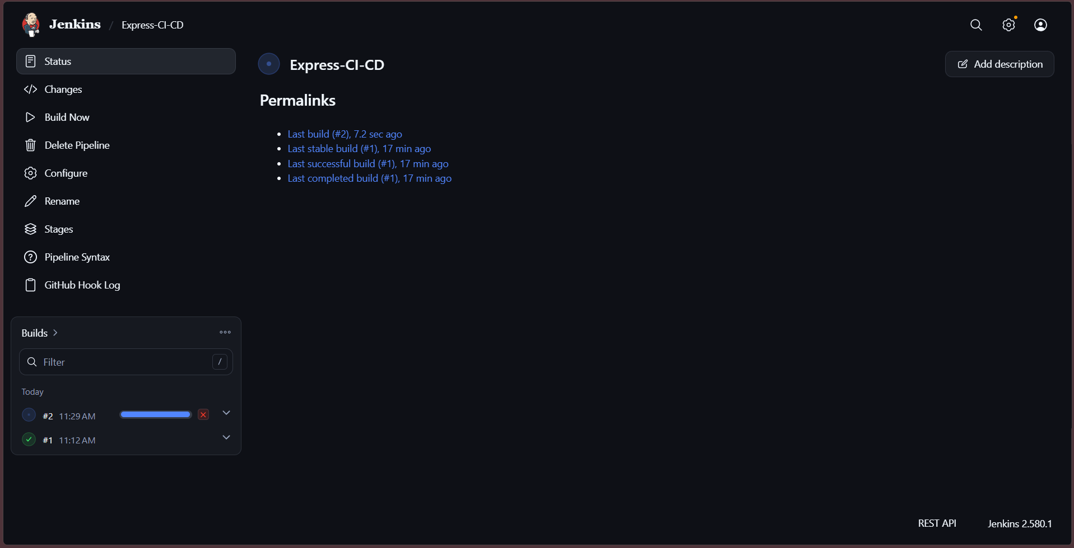

Backend pipeline proof
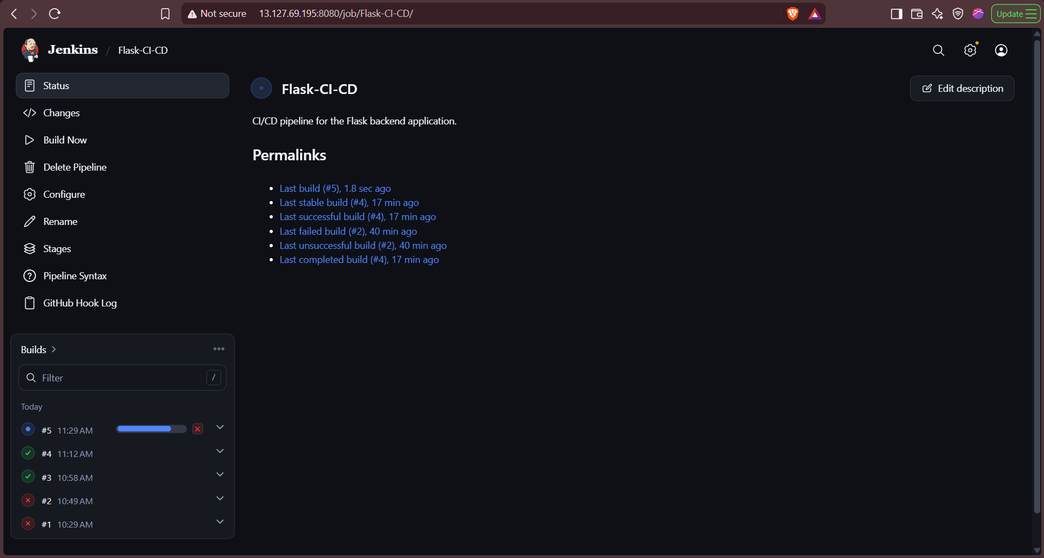

Frontend Change Proof (Frontend IP -> http://13.127.69.195:3000/)
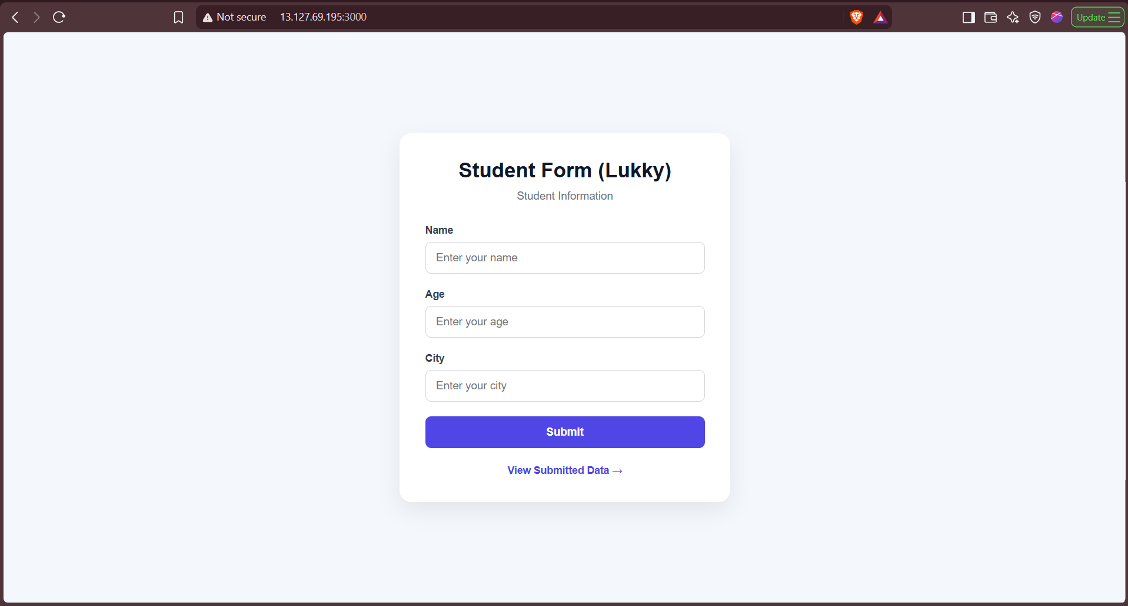

Backend Change Proof (Backend IP-> http://13.127.69.195:5000/)
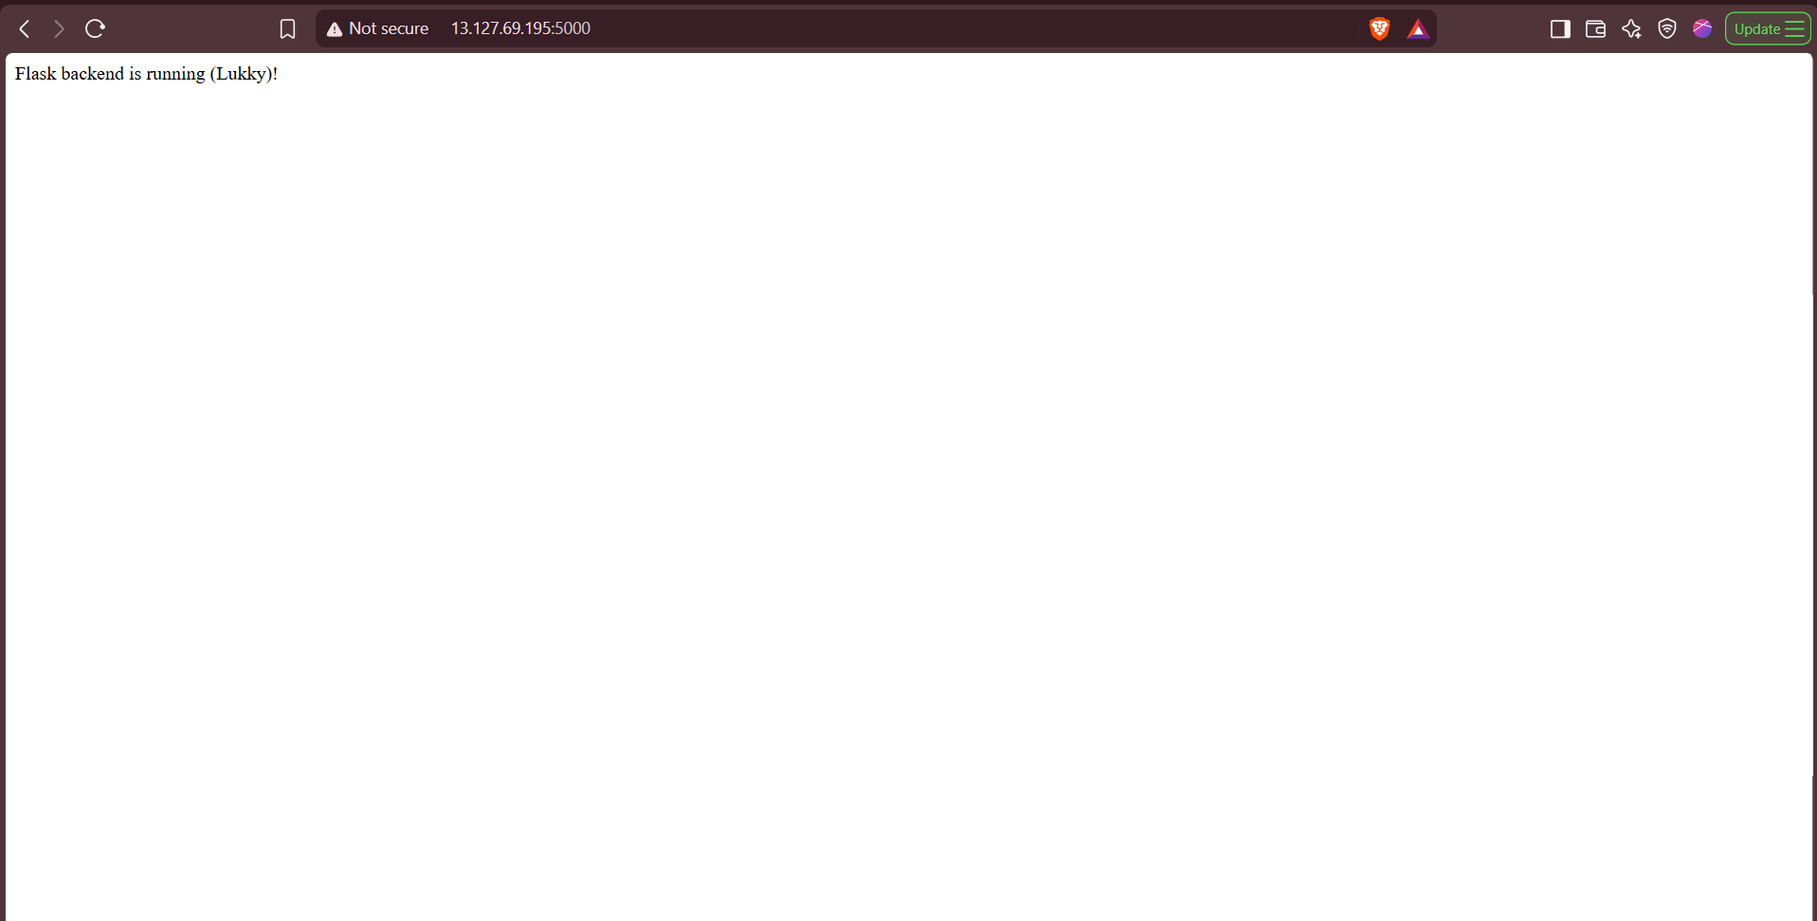

Jenkins Proof (Jenkins IP -> http://13.127.69.195:8080/)
